ORDER FORM

BOOKS COST No. OF COPIES LANGUAGE AMOUNT

CREATIVE LEARNING BOOKR25.00
Available in English, Afrikaans, Xhosa and Zulu(each)

LEADER'S GUIDE PREPARATION BOOKR60.00
Contains 10 lessons. Helps Teachers in preparing learners for the(each)
examination. Books may not be photocopied except for learners
worksheeets. Each Teacher should have their own copy. Available
in English.

LIVELY LEARNINGR20.00
A useful Teacher training manual. NOT required for the examination(each)
Available in English only

Name: …………………………………… TOTAL AMOUNT ENCLOSED R ……………..…

Address: ………………………………………………… PAYMENT MUST BE MADE WITH THE ORDER

………………………………….……………….

 (h) ………..…… (w) …………..….. (cell) …………..…….. Fax: ………..…….. E-mail ………………….
TARGET TIMOTHY
2013

LEADER’S GUIDE (Preparation Book/Curriculum) is available in English from the SANSSA Regional Office. This contains 10 lessons and graded activity sheets based on the Scripture Theme.

The cost is R60,00 per book.
>>>>>>>>>>>>>>>>>>>>>>>>>>>>>>>>>>>>>>>>>>>>>>>>

PROCEDURE
☺ Information brochure sent out in October or
November 2012 (this form).

☺ Please send the attached Application Form request for an
Official Entry Form" to the address indicated thereon.
Give the approximate number of learners in each grade by
28th February 2013.

☺ SANSSA will then send you the "Official Entry Form"
(For names of each learner). These should be completed
and returned to the SANSSA Office in your Region,
WITH THE FEES PLEASE, by: 21th May 2013.

☺ Teacher's Topic will be set on chapters in the
"Creative Learning” book. Copies of which can be purchased for R25.00 from your SANSSA Regional office.

☺ SANSSA will return the Official Entry Form, which will
indicate the number that has been allocated to each
learner, the question papers and the instructions to the
Commissioner end of MAY 2013.

☺ Participants write the Examination in
JUNE or JULY 2013

☺ Commissioners must return the question papers
together with “OFFICIAL ENTRY FORMS” to SANSSA
immediately - SEPTEMBER - for marking.

☺ Certificates will be posted in
November 2013
________________________________________
FACTS ABOUT SANSSA
SANSSA is a Non-profit Organisation established to promote Christian Education in the Churches throughout South Africa. Founded in 1915. SANSSA is an interdenominational service agency committed to the total teaching ministry of the Church to children, youth and adults.
(NPO 012-420)
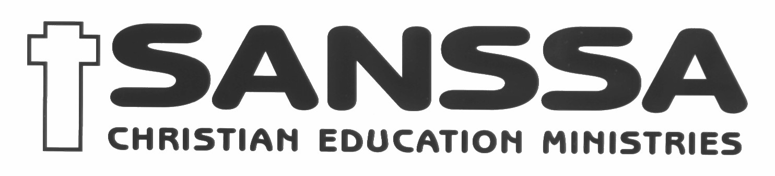
SCRIPTURE KNOWLEDGE EXAMINATION

produced by

SANSSA
CHRISTIAN EDUCATION MINISTRIES
Non-profit organisation No. 012-420 NPO
www.sanssa.org

sponsored by

A project for the development of ministry to children in South Africa
2

REQUEST FOR ENTRY FORMS FOR 2013 SCRIPTURE KNOWLEDGE EXAMINATION
Names of all pupils wishing to enter must be entered on the SKE Official Entry Form. In order to obtain an "Official Entry Form" , please complete THIS FORM AND MAIL IT TO THE SANSSA ADDRESS BELOW AS SOON AS POSSIBLE.

Name of Ministry (Church, Sunday School, Organisation): ………………………………………………………………………………….……..

Name and address of person to whom the Official Entry Form must be sent: ………………………………………………………………...…… ………………………………………….…………………………………………………………………………………………………….…...…..

Code ………..., Tel No: ( ) ………….……Cell No: …….………………… Fax: ( ) ………….……. E-mail: ………………...….
INFORMATION

HOW TO ENTER
The names of all learners wishing to enter must be listed on the "Official SKE Entry Form". These are obtainable by completing the attached "Request for Official Entry Forms" tear-off slip.

Please request these NOW and return completed Official Entry Forms with the required Entry Fees to reach SANSSA Regional Office by 21st May 2013.

Instructions and question papers will be mailed to each entrant prior to the examination date.

LATE ENTRIES MAY NOT BE ACCEPTED.

ENTRY FEES
Member Church: R7.50 per learner
R10.00 per teacher
Non Member Church: R8.00 per learner
R10.50 per teacher

EXAMINATION DATE
June or July 2013
RESULTS
As some 12 000 entries are received each year, results will only be available in November 2013 whereupon you will be notified by post.

AWARDS
Certificates are awarded to all learners achieving 40 % or more. Learners who achieve 80-89% will receive a First Class Certificate. Learners who achieve 90-100% will receive a Distinction Certificate.

LANGUAGE MEDIUM
Question papers are available in all South Africa's official languages, depending on the availability of translators.
SANSSA SCRIPTURE KNOWLEDGE EXAMINATION JUNE 2013
________________________________________________________
THEME:
JESUS – WHAT HE DID.
________________________________________________________

LESSONS
 | Jesus cares about our needs. | John 6: 1 – 14
 | Jesus calls the first Disciples. | Luke 5: 1 – 11  & 27 - 32
 | Jesus changes lives. | Luke 19: 1 - 10
 | Jesus heals. | Luke 17: 11 – 19
5 | Jesus teaches. | Luke 10: 25 - 37
6 | Jesus died. | Mark 15: 1 – 37  & 38 - 39
7 | Jesus lives. | Luke 24: 1 – 12  & 13 - 35

PLEASE NOTE:
* English language questions and memory work will be
based on NIV and GOOD NEWS versions of the Bible.
* All questions will be based on the teaching contained in
the Scripture portions.
_________________________________
GRADES | LESSON | MEMORY  VERSES  Psalm 103
Grades 1,2, 3 (Oral) | 1,2 & 3 | vs 1-3
Grades 4 & 5 | 1,3,&4 | vs 1-4
Grades 6 & 7 | 1,2,3,&5 | vs 1-5
Grades 8 & 9 | 2,3,4,5 & 6 | vs 1-8
Grades 10 & 11 | 1,2,3,4,5,&6 | vs 1-10
Grades 12 | 1 to 7 | vs 1-14
Teachers | 1 to 7  + Teacher’s  Topic | vs 1-17
Teacher's Topic:

Chapter 6 CREATIVE LEARNING BOOK
___________________________________________________
NB: The Creative Learning Book is available at
R25.00 per copy from your SANSSA Regional
Office
GRADES No of LearnersGRADES No of Learners SEND THIS APPLICATION FORM TO:

Oral Grades 1,2 and 3Grades 8 and 9

Grades 4 and 5Grade 10 and 11

Grades 6 and 7Grade 12

Teachers

Closing date for this application form is 28TH FEBRUARY 2013

Closing date for Official Entry Form is 21ST MAY 2013

Examination date is JUNE 2013


SANSSA SKE OFFICE,
P O Box 66109
BROADWAY, 2020

Tel: 011 614-2329
Fax: 011 618-1590
Cell: 082 662 8362
(Ask for Tryphina Mpembe)

